#select desktop version:

POST INSTALLATION TASK :

- Understanding devices and device drivers
- Everything would be done through Device Manger.
- hit “run” and “devmgmt.msc”
- Device driver could be installed, updated, deleted and rolled back
- Digital signer: Microsoft windows :::: recommend
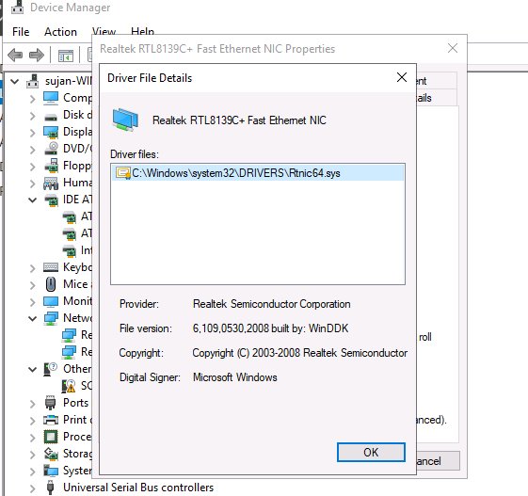
digital signer: Microsoft Windows

- Understanding the registry and services
- Registry: file where hardware and software configuration of in windows are saved.
A central hierarchical database used in Windows 98, Windows CE, Windows NT, and Windows 2000 used to store information that is necessary to configure the system for one or more users, applications, and hardware devices.
The Registry contains information that Windows continually references during operation, such as profiles for each user, the applications installed on the computer and the types of documents that each can create, property sheet settings for folders and application icons, what hardware exists on the system, and the ports that are being used.

- Services : process that gets executed.

What is Microsoft service account?
- A Microsoft service account is an account used to run one or more services or applications in a Windows environment. ... The service account provides the security context for the service — in other words, it determines which local and network resources the service can access and what it can do with those resources

Local System: This is a built-in account with the most privileges in a Windows
OS. It is also known as a superuser, and this account is more powerful than an
admin account.
NT Authority\LocalService: This is a built-in account with the same privileges as
members of the users group.
NT Authority\NetworkService: This is a built-in account that has more
privileges than members of the users group.

What do you mean “ADDING SERVICE DEPENDENCIES, WHY AND HOW ITS DONE.”
-

- Understanding Windows Server initial configuration
- #Initial setup
- Domain Name
- Ip Address
- Time zone
- Turning Off IE Enhanced security
RDP

- Chapter exercise—performing an initial Windows Server configuration
-

SETTING UP WINDOWS SERVER 2019
# windows admin center

DIRECTORY SERVICES
#
In a windows domain.. which is the only place you’ll encounter this message, there are 2 types of servers. There are Member servers, and there are Domain Controllers. There is a third class of servers called standalone servers I’ll address towards the end..
Member servers are any server that have been joined to the domain, but dont serve domain controller functions. These can be email servers, sharepoint servers, print servers, file servers… They are clients of the domain.
Then there is Domain Controllers. These are the central systems of your domain. They provide desired state configuration via GPO. They provide authentication, authorization, and even auditing. They, in combination with GPO, are the central security mechanism to your domain. They host the domain name. They distribute the GPO’s to clients (memberservers). They synchronize information between them. They provide WINS and DNS. The hold the accounts for users and computers.
If your DC is compromised.. your whole network is compromised..
Promote this server to a domain controller.. in any server since 2012.. means you have added the ADDS (active directory domain services) role on the server, and it’s waiting for the second half of the action.. called promotion. The act of promotion adds the system into DNS as an AD domain controller, ads it into AD as a domain controller, and if no Domain or Forrest exists (the first DC to be stood up in an environment).. then it creates those things.
What does promote this server to a domain controller actually mean? It means you are turning a member server into a domain controller.. or in rarer cases.. taking a standalone server (a server that’s not part of a domain at all) and creating a active directory domain and active directory forrest.

ADDING ROLES

Internet Information Services (IIS) is a flexible, general-purpose web server from Microsoft that runs on Windows systems to serve requested HTML pages or files.
An IIS web server accepts requests from remote client computers and returns the appropriate response. This basic functionality allows web servers to share and deliver information across local area networks (LAN), such as corporate intranets, and wide area networks (WAN), such as the Internet.
A web server can deliver information to users in several forms, such as static webpages coded in HTML; through file exchanges as downloads and uploads; and text documents, image files and more.

CONFIGURING WINDOWS SERVER

GROUP POLICY

VIRTULIZATION IN WINDOWS SERVER

STORING DATA IN WINDOWS SERVER

UPDATING AND TROUBLE SHOOTING

CORE INFRASTRUCTURE SERVICES

POWERSHELL

